Day-1 tasks:

Session1:

To execute different git commands:

Created repo called Sklab_classgit on Github account.

>>git remote add origin <https://github.com/Deekshithagi/Sklab_classgit.git>

>>git init (to initialize a Sklab_classgit repo in a project directory.

>>touch README.md (created file)

>>git add README.md (to add changes in the specific file from working directory to the staging area)

>>git commit -m”modified the file”

>>git push origin main (pushed changes to the remote repo)

Similarly created an empty file called file1.md

Result:

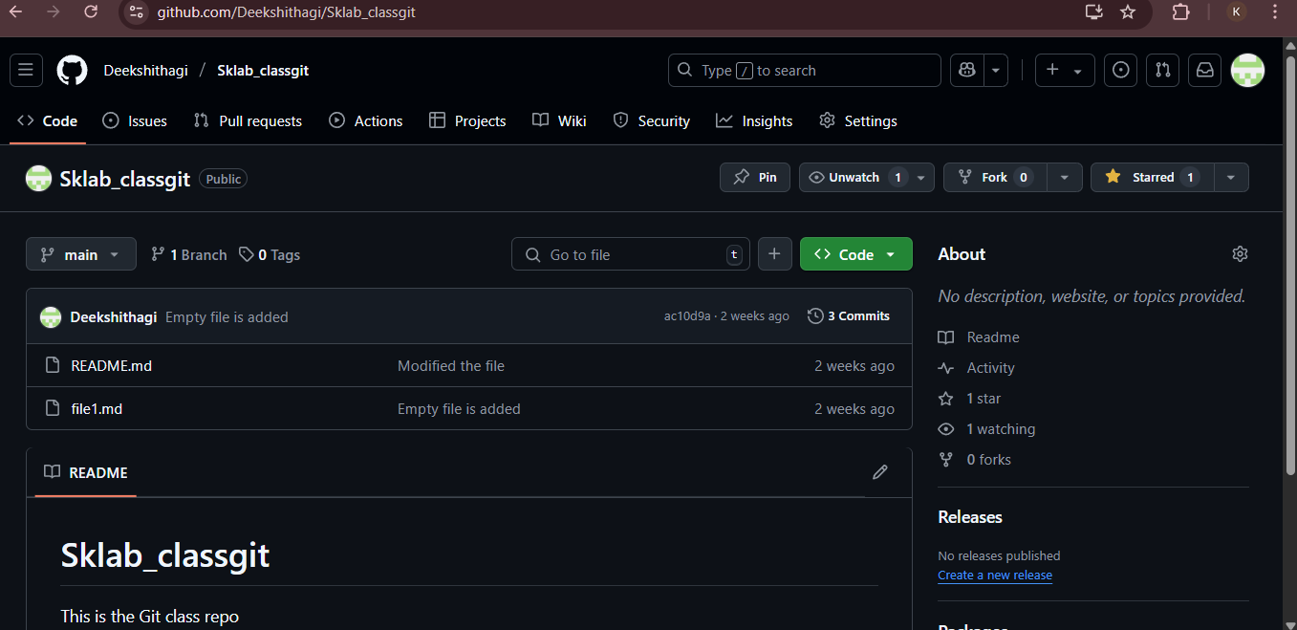

Sessoin2:

To find the bugs in the given factorial application and to write the test cases for it:

